
Personal Development Planner
My goal is… |  | My main focus is… |  | MY BUCKET LIST
 |  |  |  | ☐
 |  |  |  | ☐
 |  |  |  | ☐
 |  |  |  | ☐
 |  |  |  | ☐
Habits I want to BUILD |  | Habits I want to BREAK |  | ☐
 |  |  |  | ☐
 |  |  |  | ☐
 |  |  |  | ☐
 |  |  |  | ☐
 |  | 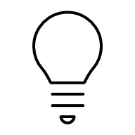
Personal Growth |  | Health & Wellness |  | Career & Learning
Relationships |  | Financial |  | Spiritual/Mental
source: www.neworchards.com

