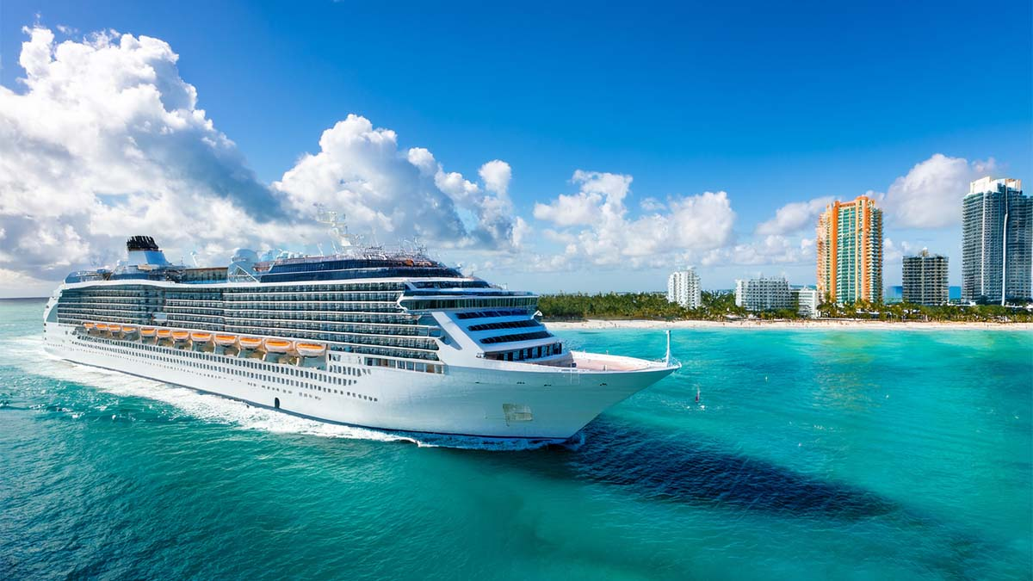
Cruise Packing List
Clothing/ Accessories/ Electronics
☐ |  |  | ☐ |  |  | ☐
☐ |  |  | ☐ |  |  | ☐
☐ |  |  | ☐ |  |  | ☐
☐ |  |  | ☐ |  |  | ☐
☐ |  |  | ☐ |  |  | ☐
☐ |  |  | ☐ |  |  | ☐
☐ |  |  | ☐ |  |  | ☐
☐ |  |  | ☐ |  |  | ☐
☐ |  |  | ☐ |  |  | ☐
☐ |  |  | ☐ |  |  | ☐
☐ |  |  | ☐ |  |  | ☐
Toiletries/ Medications/ Other Miscellaneous Items
☐ |  |  | ☐ |  |  | ☐
☐ |  |  | ☐ |  |  | ☐
☐ |  |  | ☐ |  |  | ☐
☐ |  |  | ☐ |  |  | ☐
☐ |  |  | ☐ |  |  | ☐
☐ |  |  | ☐ |  |  | ☐
☐ |  |  | ☐ |  |  | ☐
☐ |  |  | ☐ |  |  | ☐
☐ |  |  | ☐ |  |  | ☐
☐ |  |  | ☐ |  |  | ☐
☐ |  |  | ☐ |  |  | ☐
source: www.neworchards.com

