
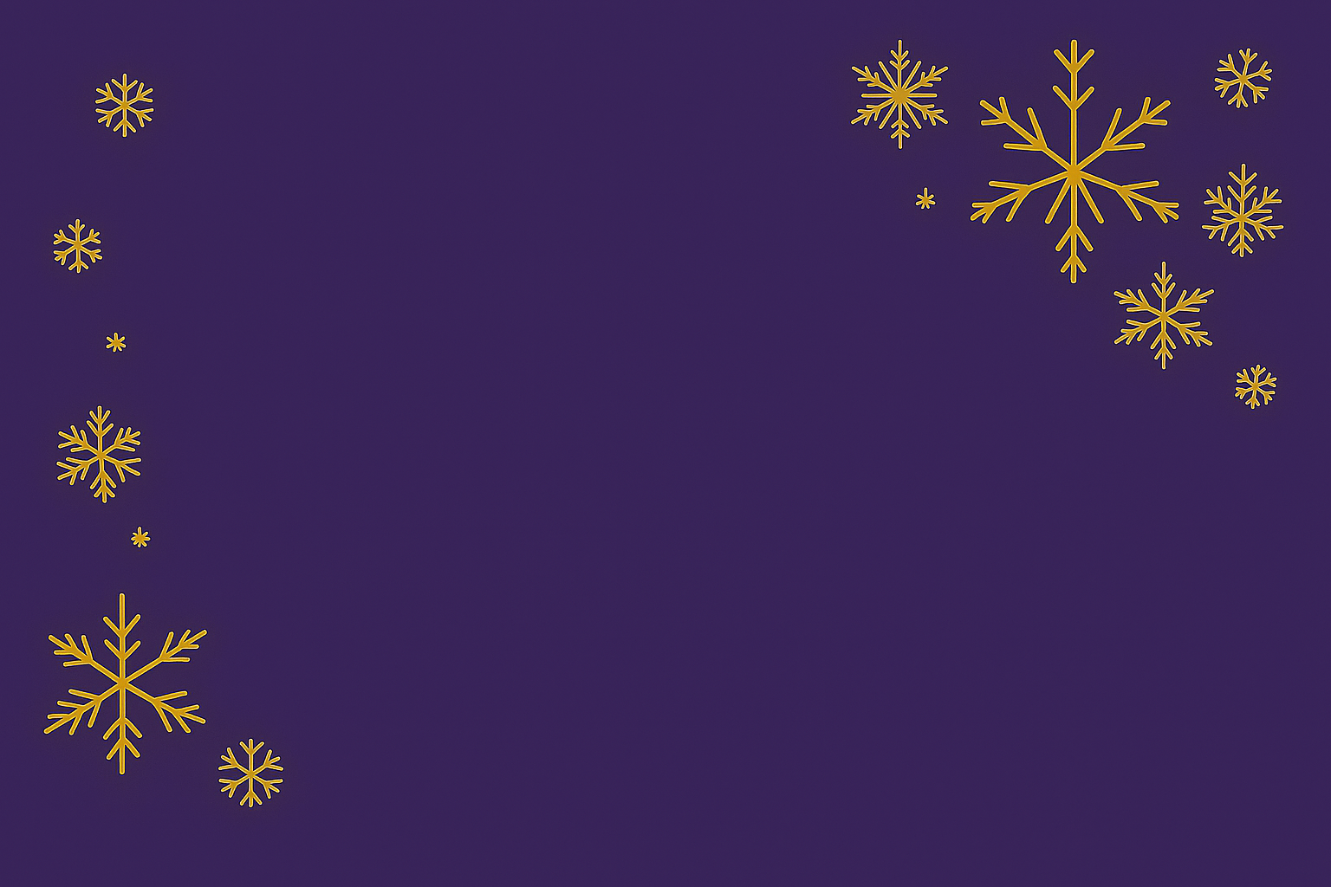
Happy Holidays!

Eat, drink,
and be merry!

Cheers,
[Your Name Here]

